## Merchant

Demo date: Feb 7, 2025  
Scoping start date:

MSA Signature Date: Feb 19, 2025  
Onboarding Kick Off Date: Feb 21, 2025

[If Exists] Opt Out Date:   
Go Live Date:

GTM POC: Paula  
Implementation POC:Jeff

ERP: QBO

Tax Integration:

### 

### Key people at Merchant

### Accountant: Justin <https://www.linkedin.com/in/justinstraight>

### CFO: Justin <https://www.linkedin.com/in/justinstraight>

### Customer service rep who is really involved:

* Account Receivable POC: Justin <https://www.linkedin.com/in/justinstraight>
* Billing POC Justin <https://www.linkedin.com/in/justinstraight>

### Etc.

### 

| Notes Sections [Ops International Team to Ignore] *(AE/ Implementation to fill)*   * Info on how merchant bills   + Flat Subscription   + Implementation fee * Is there any important merchant relationship information? - We are **only** rolling on out on their LOS “Loan Origination System” business- basically their SaaS platform  - In a future state, they want to scope out and purchase a Tabs upsell/expansion for their Marketplace business (this side has remittances but we aren’t touching this yet) - Feature request: Ability for customers to see past overdue invoices in the customer portal. Arjun said Q3. I didn’t give the timeline to Justin   1) What is the merchant temperament?   Justin is very nice but a bit all over the place. Rarely responds to emails or texts. Only time we talked was when we had time on the calendar   2) Is there a key POC: (i.e.: who is the buyer/decision maker?) Justin Bernard (CEO) had to approve  3) What are the Tabs features that the key POC cares about? - automated invoice creation  - renewal dash - set up autocharge for bank payments  - Feature request: Ability for customers to see past overdue invoices in the customer portal. Arjun said Q3. I didn’t give the timeline to Justin |
| --- |

### 

### Company summary *(AE to fill)*

Summary of what company does:  
LoanWell is a cloud-based platform that provides an end-to-end solution for lenders, encompassing the entire lending process from intake and origination to underwriting, closing, servicing, and reporting.

Goals (North star)  
*(AE/ Implementation to fill)*

What is the merchant's goal? What pain are we solving? Why are they buying Tabs?

Pains:  
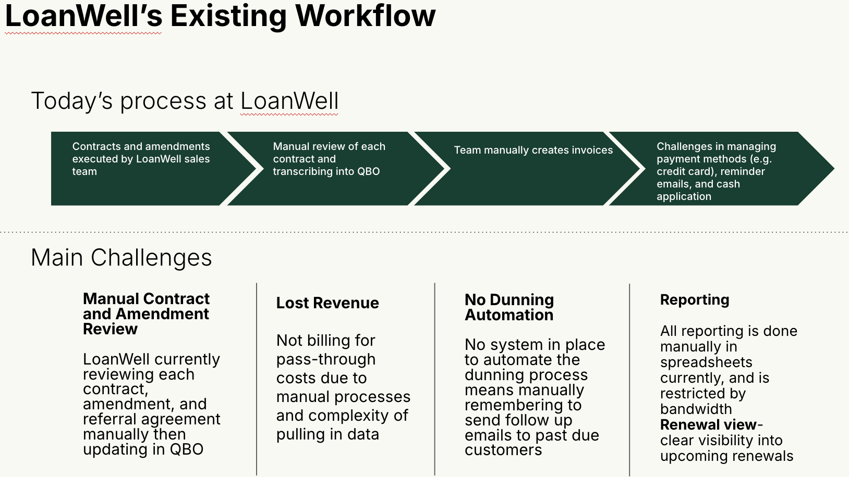  
  
Goals:

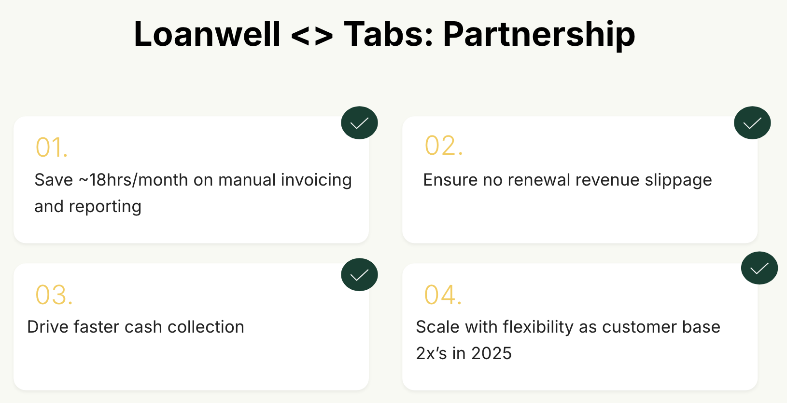  
Why they’re buying Tabs:

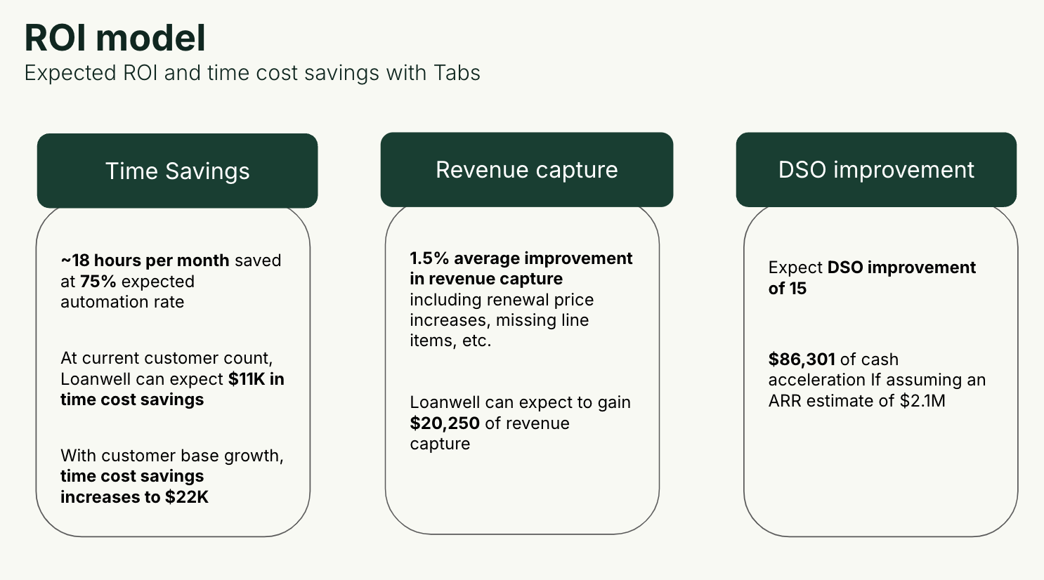  
Is there an opt out clause? If so, what is the merchant looking for so they do not exercise it?

No

### Billing model *(AE/ Implementation to fill)*

* Are there unique things about the customer creation process for this merchant?

No

* Information on how merchant bills  
    
  Flat Subscription

Implementation fee

* How contract is broken up
* One off things to know about the merchant
* - We are **only** rolling on out on their LOS “Loan Origination System” business- basically their SaaS platform   
  - In a future state, they want to scope out and purchase a Tabs upsell/expansion for their Marketplace business (this side has remittances but we aren’t touching this yet)  
  - Feature request: Ability for customers to see past overdue invoices in the customer portal. Arjun said Q3. I didn’t give the timeline to Justin

### Contract Processing Steps *(Implementation/Success to fill)*

1. Steps to process
   1. Service Start Date: Locate the "Effective Date" or "Subscription Start Date" in the agreement or amendment.
   2. Months of Service: Identify the initial subscription term and any renewal conditions.
   3. Item Name: Look for the specific service or software solution being provided (e.g., "LoanWell SaaS Solution" or "Spanish Translation Amendment").
   4. Item Description:
      1. [HERE](https://docs.google.com/spreadsheets/d/1ua2FafRqgvF1MybkvA_2_wyPfqz9BEx5KQnkoY9ey3A/edit?gid=0#gid=0)
   5. Integration Item: Leave blank.
   6. Billing Type: Flat.
   7. Total Price: Identify the total subscription fees, any additional implementation costs, and changes in pricing due to amendments.
   8. Quantity: Look for any specifications on the number of users, licenses, workflows, or other relevant units.
   9. Start Date: Confirm the official commencement date from the contract or order form.
   10. Periods: Verify whether the agreement is subject to renewal, extension, or modifications based on scope changes.
   11. Frequency: Locate the invoicing schedule (e.g., upfront, annual, upon renewal)
       1. Implementation is always one time
   12. **Notes: Amendment number and partner for amendments to be added in additional fields**
2. Anything to ignore in contracts?
3. Specifics processing things the merchant has requested that may differ by contract (e.g. always back-date invoice date to final day of the month)
4. Default Service Term
   1. If None Listed, Ops Default is 1 Year
5. Default Net Payment Terms
   1. If None, Ops Default is 0
6. Default Billing Frequency
   1. If None Listed, Ops Default is Monthly
7. How do we handle taxes as a line item?
   1. If None Listed, Ops Default is every tax line item becomes a BT

### Events Processing (if necessary) *(Implementation/Success to fill)*

* Any important information on events billing

Integration Items Processing (if necessary)  
*(Implementation/Success to fill)*

* What are the instructions for assigning integration items?
* Example: All Statsig integrations items should be labeled as “Sales”
* Example: All “Pinata” integration items should be labeled as “Software Subscription Bundle” unless otherwise noted by Merchant

Post Processing Communications (if necessary)  
*(Implementation/Success to fill)*

* Does the Ops Team need to notify anyone on the team re: completion of processing batches in Implementation or Active phase?
* Who needs to be notified and when?
  + Example:
    - Who: Customer Success [Azmat Aziz] needs to be notified
    - Where: Messari internal merchant channel
    - When: contracts are processed [Merchant Phase: Active]

### Customer Information *(Implementation/Success to fill)*

* Any important information on specifics customers of this merchant
  + Special memo’s certain invoices require
  + Invoice changes due to merchant/customer relationship

### Feature Requests *(AE/Implementation/Success to fill)*

* FR 1
  + What is it
  + Why it's important
  + Urgency

### Rewatch Calls *(AE/Implementation/Success to fill)*

Rewatch by dates   
  
Daniel’s calls:  
<https://www.loom.com/share/bac912cbd6dc4231b516156365d6a96d>

<https://www.loom.com/share/34a955ea6f9d4008a04afd677221dc0a>

<https://www.loom.com/share/1e858d80ce8e4152927c1ca8d90eb913>

<https://www.loom.com/share/e8919517428d43b687dbeff1b95b55be>

Mine:

<https://us-56595.app.gong.io/call?id=283906221102217458&account-id=442100437119775226>

<https://us-56595.app.gong.io/call?id=3577658367042410032&account-id=442100437119775226>

<https://us-56595.app.gong.io/call?id=3550685925728943106&account-id=442100437119775226>

<https://us-56595.app.gong.io/call?id=7504558327580655886&account-id=442100437119775226>